✅ Whenever an Exception Occurs, We Have Three Options
- Handle the exception
- Declare (Duck) the exception
- Catch and Rethrow the exception

1️⃣ Handling the Exception (try–catch)
Handling means:
- You write try block for risky code.
- You write catch block to deal with the problem.
- Program continues normally after handling.
try {
int x = 10 / 0;
} catch (ArithmeticException e) {
System.out.println("Cannot divide by zero");
}
Here:
- Exception is caught.
- Proper action is taken.
- Program does not crash.
Handling means you are taking responsibility.

2️⃣ Ducking the Exception (Declaring using throws)
Ducking means:
- The method does NOT handle the exception.
- It informs the caller that this method may throw an exception.
- It uses the throws keyword in the method signature.
void alpha() throws IOException {
FileReader fr = new FileReader("file.txt");
}
Here:
- alpha() is not handling IOException.
- It informs the caller method.
- The caller must either handle it or declare it again.
Ducking means:
“I am not handling it. Caller, you decide what to do.”
It is not ignoring the exception.
It is passing responsibility to the caller.
If no method handles it, program will terminate.

Important Rule About Ducking
- Ducking is mainly used for checked exceptions.
- For unchecked exceptions, compiler does not force you to use throws.

Eg: Ducking_Exception

3️⃣ Rethrowing an Exception
Sometimes:
- You catch the exception.
- Do some work (like logging).
- Then send the same exception again to the caller.
This is called rethrowing.
void withdraw() throws Exception {
try {
int x = 10 / 0;
} catch (ArithmeticException e) {
System.out.println("Logging the error");
throw e; // rethrowing
}
}
Here:
- Exception is caught.
- Some action is done.
- Same exception is sent to caller.
After throw, remaining code in that block will NOT execute.
If you want something to execute always, use finally.

Eg: RethrowExample

throw vs throws
🔹 throw
- Used inside method body or catch block.
- Used to actually throw an exception object.
- Execution stops immediately after it.
Example:
throw new ArithmeticException("Invalid operation");
Eg: ThrowKeywordExample

🔹 throws
- Used in method signature.
- Used to declare that method may throw exception.
- Does not throw anything by itself.
Example:
void test() throws IOException

Checked vs Unchecked Exceptions
✅ Checked Exceptions
- Compiler checks them at compile time.
- Compiler forces you to handle or declare them.
- Example: IOException, SQLException.
These are usually external problems:
- File not found
- Database connection failure
- Network issues

✅ Unchecked Exceptions
- Occur at runtime.
- Compiler does NOT force you to handle them.
- They are subclasses of RuntimeException.
Example:
- ArithmeticException
- NullPointerException
- ArrayIndexOutOfBoundsException

Important Clarification
❌ Checked and unchecked are NOT both runtime exceptions.
✔ Only unchecked exceptions are runtime exceptions.
✔ Checked exceptions are checked at compile time.

Industry Recommendation
🔹 Checked Exceptions
Usually declared (ducked) or handled depending on design.
🔹 Unchecked Exceptions
Generally:
- Do NOT catch everywhere.
- Fix root cause.
- Let them propagate to global handler (like Spring Boot global exception handler).
In modern industry:
- Business validation errors → usually unchecked.
- System / IO errors → often checked.

Is Ducking Equal to Handling?
No.
Handling:
- You catch and take action.
Ducking:
- You pass responsibility to caller.
They are completely different.

finally Block
finally block:
- Executes whether exception occurs or not.
- Executes even if return statement is present.
- Executes even if exception is thrown.
- Used to close resources like:
  - Database connections
  - File streams
  - Network connections
Example:
try {
FileReader fr = new FileReader("file.txt");
} catch (Exception e) {
System.out.println("Error occurred");
} finally {
System.out.println("Closing resources");
}

Modern Alternative (Important Missing Point)
Instead of finally, we now use:
try (FileReader fr = new FileReader("file.txt")) {
}
This is called try-with-resources.
Resources are automatically closed.
This is industry preferred.

Clean Summary
Concept | Meaning
Handling | Catch and solve the problem
Ducking | Declare using throws and pass responsibility
Rethrowing | Catch, do something, and throw again
throw | Actually throws exception
throws | Declares possible exception
Checked | Compiler forces handling
Unchecked | Compiler does not force handling
finally | Always executes

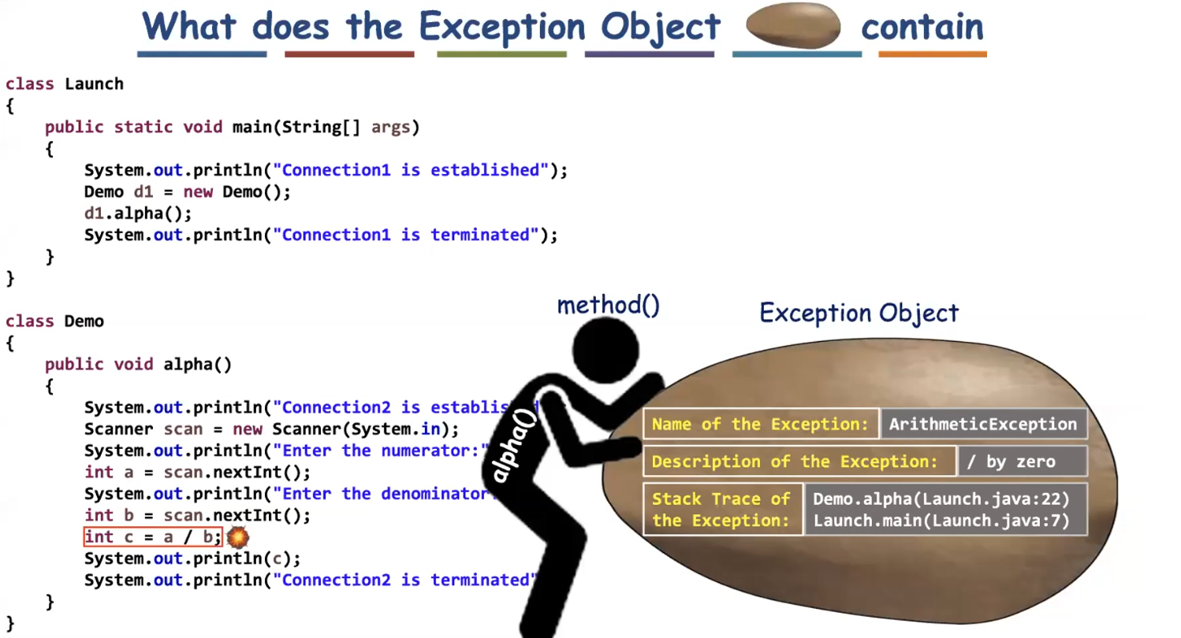
Stack trace means at which stack frame the exception has occurred.

Methods used in the catch bock to print the information are
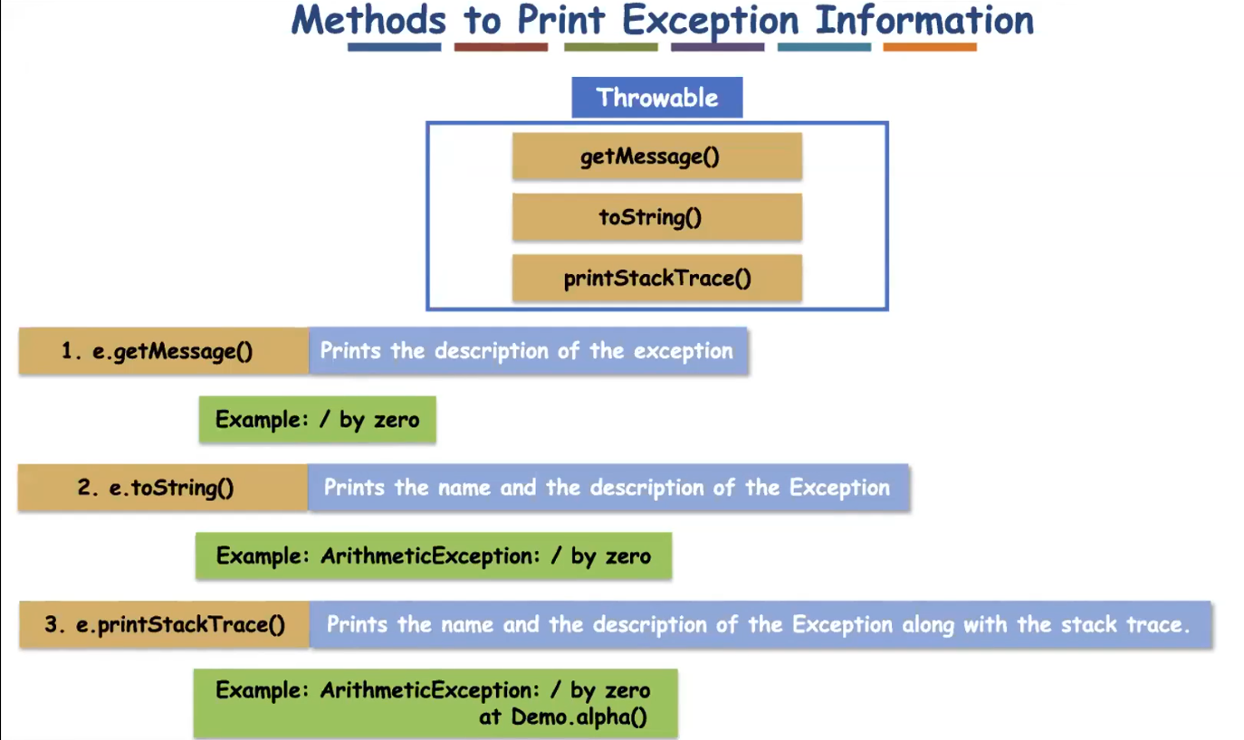
Eg: Exception_Print_Methods_Demo

✅ Important Rules About finally Block
1️⃣ finally cannot be written alone
It must be written with:
- try + catch + finally
OR
- try + finally
❌ This is INVALID:
finally {
System.out.println("Hello");
}

2️⃣ finally block will NOT execute if System.exit() is called before it
Because:
- System.exit(0) immediately terminates the JVM.
- When JVM stops, no further code executes.
- So finally block is skipped.

🔎 Why Normally finally Always Executes?
Normally finally executes in cases like:
✔ Exception occurs
✔ No exception
✔ Return statement inside try
✔ Break / Continue
But ❌ Not when:
- System.exit() is called
- JVM crashes
- Power failure 😄

🔥 Important Interview Point
If interviewer asks:
👉 “Does finally always execute?”
Correct Answer:
Finally block executes in almost all situations except when JVM is terminated explicitly using System.exit() or JVM crashes.

Eg: Finally_Block_Exit_Method

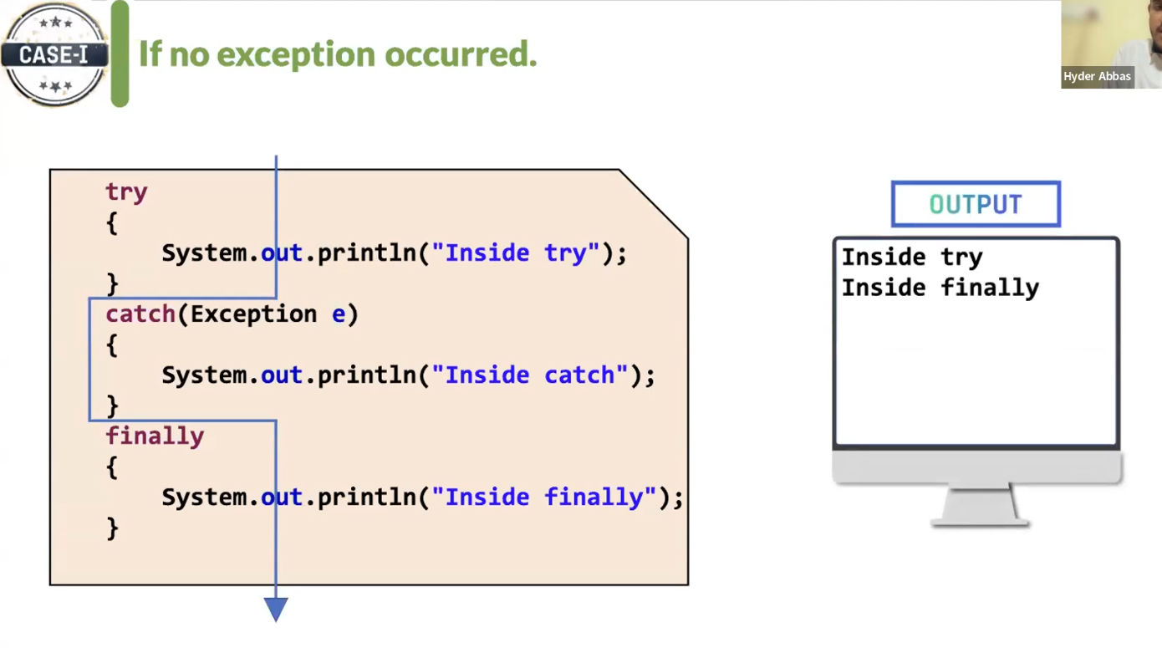

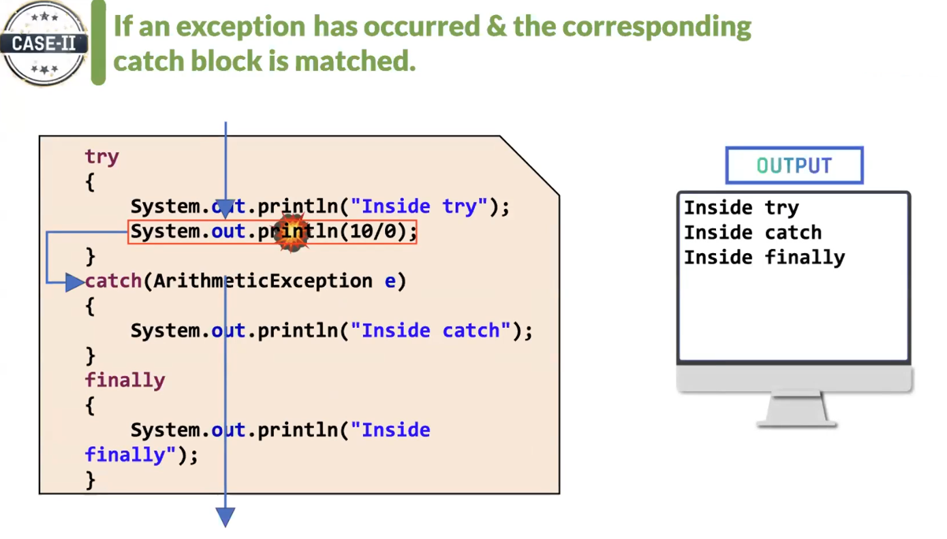

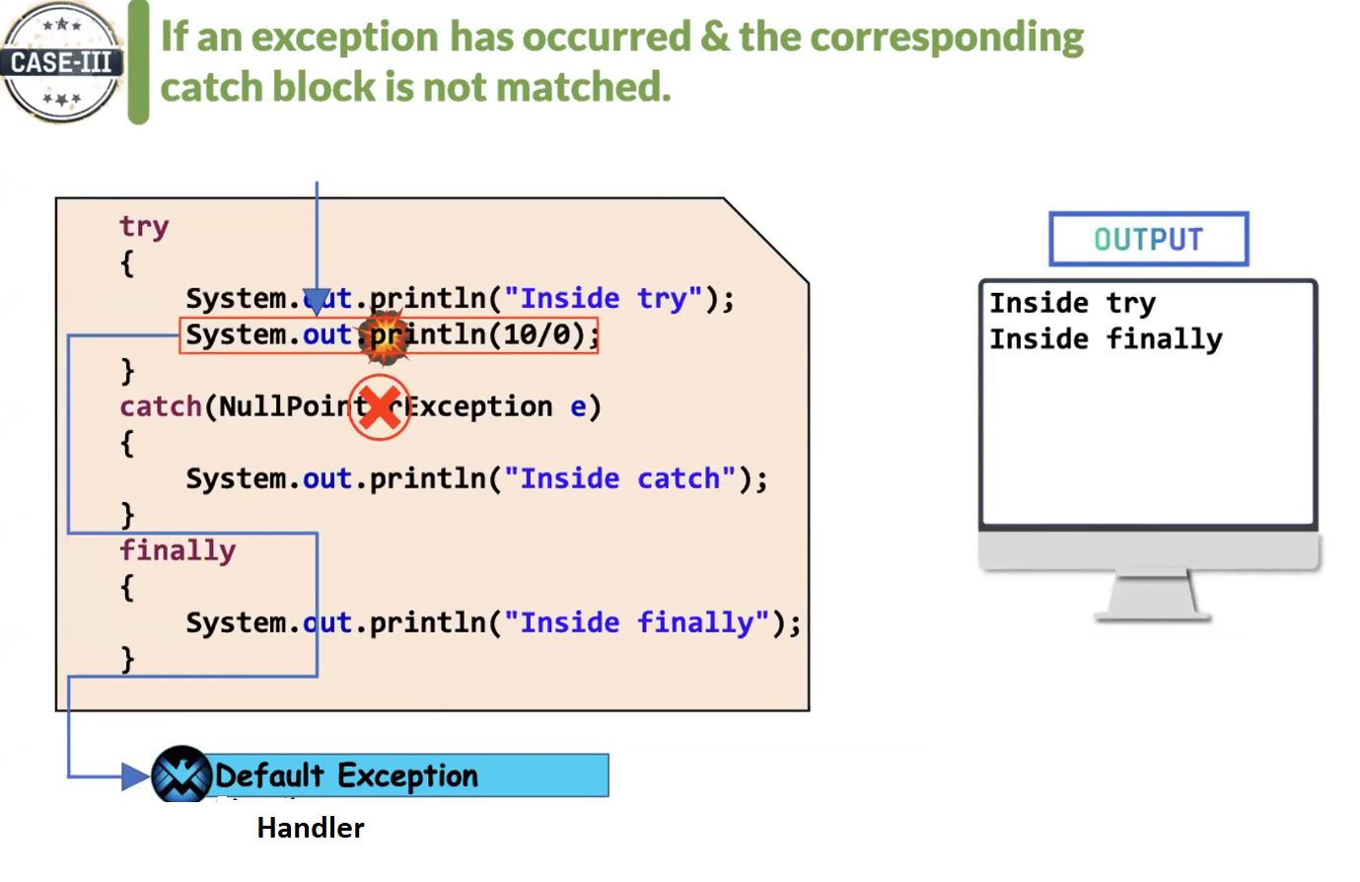

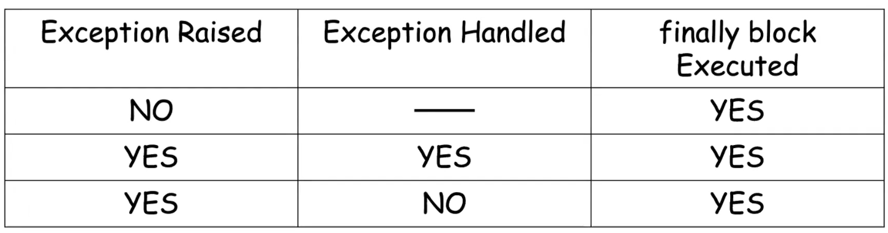

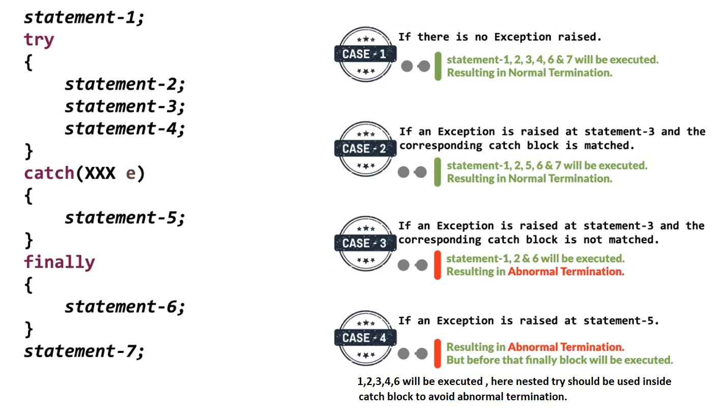

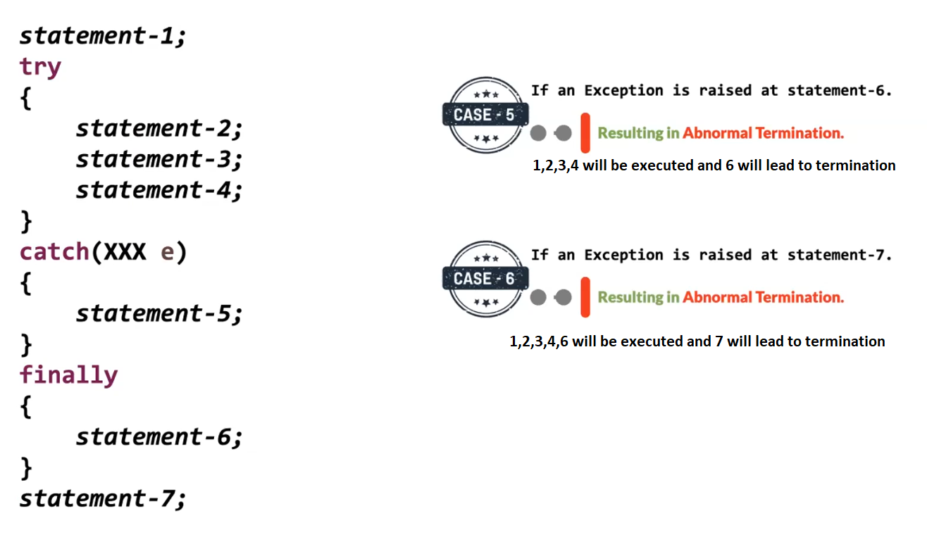

All the classes of exception are present in java.lang package

A Partially Checked Exception is:
A parent exception class whose subclasses include both checked and unchecked exceptions.
In Java, the only class that fits this definition is:
java.lang.Exception

🔍 Why is Exception Partially Checked?
Because:
Throwable
└── Exception ← Partially Checked
├── RuntimeException ← Unchecked
└── IOException ← Checked
So:
- Some children are checked
- Some children are unchecked
That’s why Exception is called partially checked.

